Player takes the roll of this little guy - 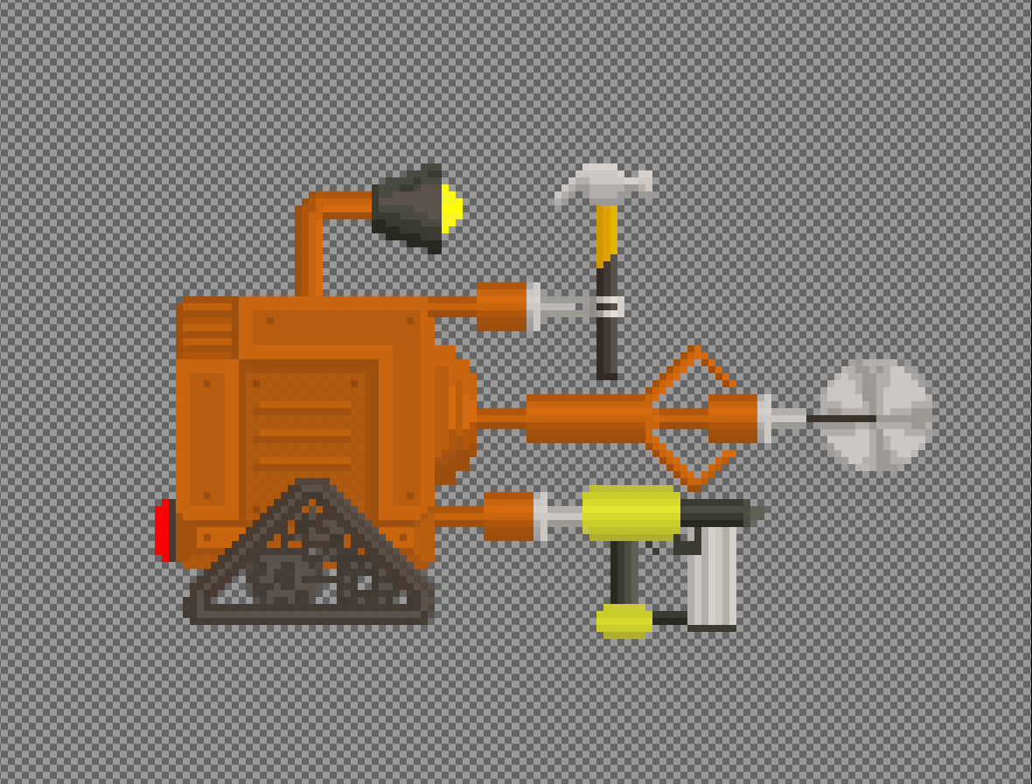

They are a construction vehicle that has decided to kill, but cannot kill directly.

The main methods for attacking workers are knocking physics objects onto their heads, or shooting nails through wooden walls (since we aren’t technically shooting directly at the person)

These are the people who we are killing

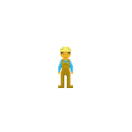

For vibes here is a blockout with some art for one of the levels

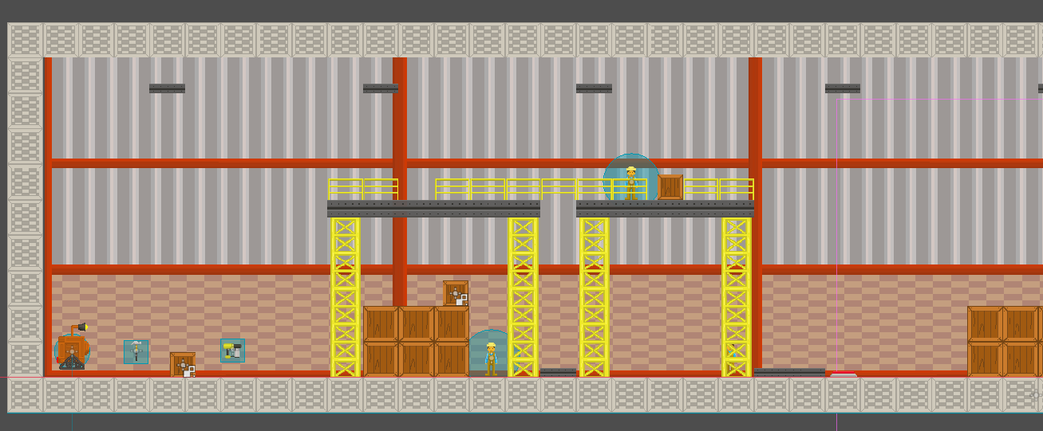

And here is a working title screen

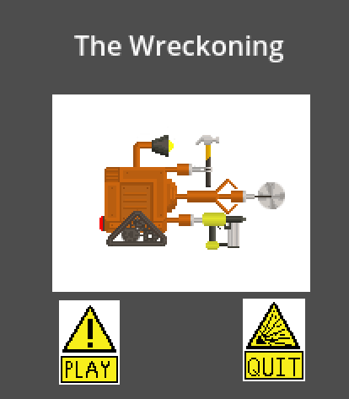

Tonally this should be very goofy and lighthearted ( think mr driller). The title is The Wreckoning